

**How To Switch Camera On The Mixer**

Last Updated: 2025-08-22

To begin with – it is important to make sure the BlackMagic TV Studio HD8 is on.

The following can be confirmed by verifying the power cable is connected behind the BlackMagic device.

The port to be checked can be found behind the BlackMagic device:

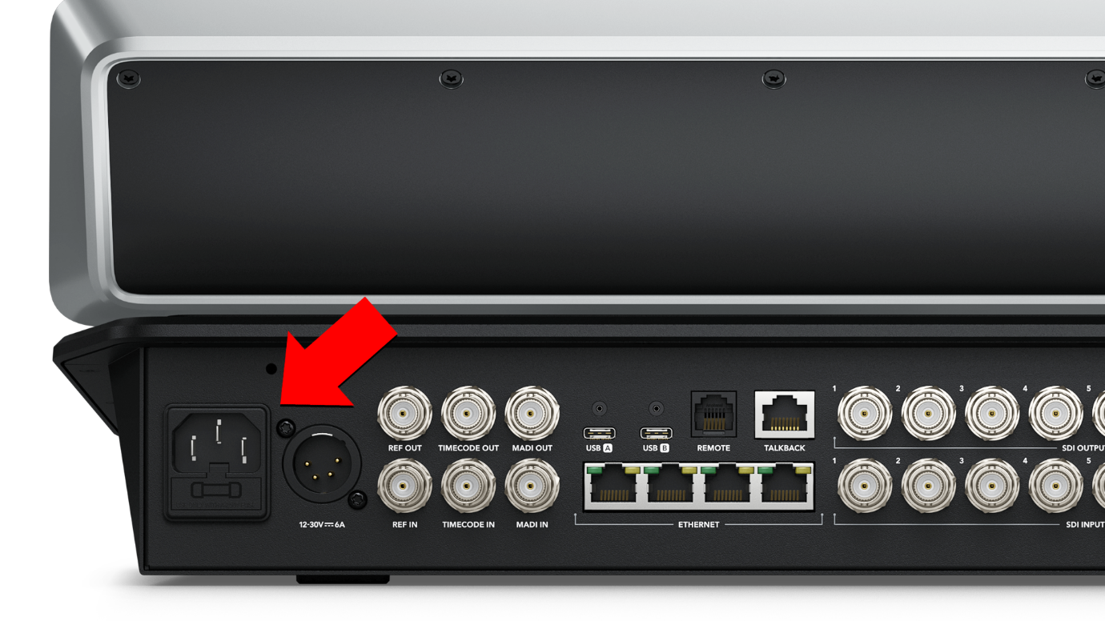

Find the following section of buttons in the bottom corner of the device:

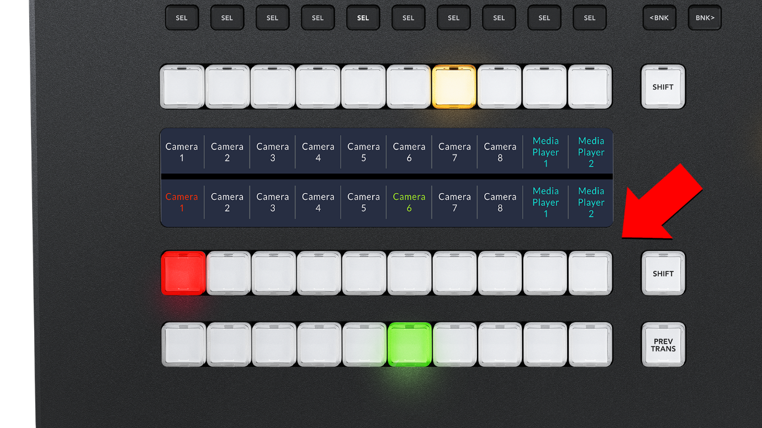

The following set of buttons have been assigned to cameras across the main hall and langar hall.

To determine the button assignments, the dark-blue interface above is the place to investigate.

According to the screenshot above, Camera 1 is assigned to the first button and Media Player 2 is assigned to the last button.

The first row of buttons below are known as Program buttons:

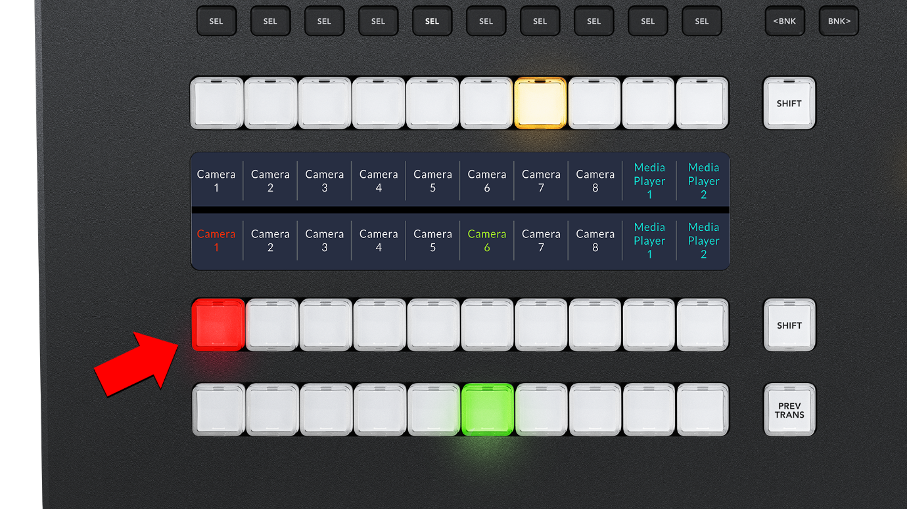

In simple terms – the Program button selected here is what will be projected to the large screen in front of you for everyone to see.

The second row of buttons are known as Preview buttons:

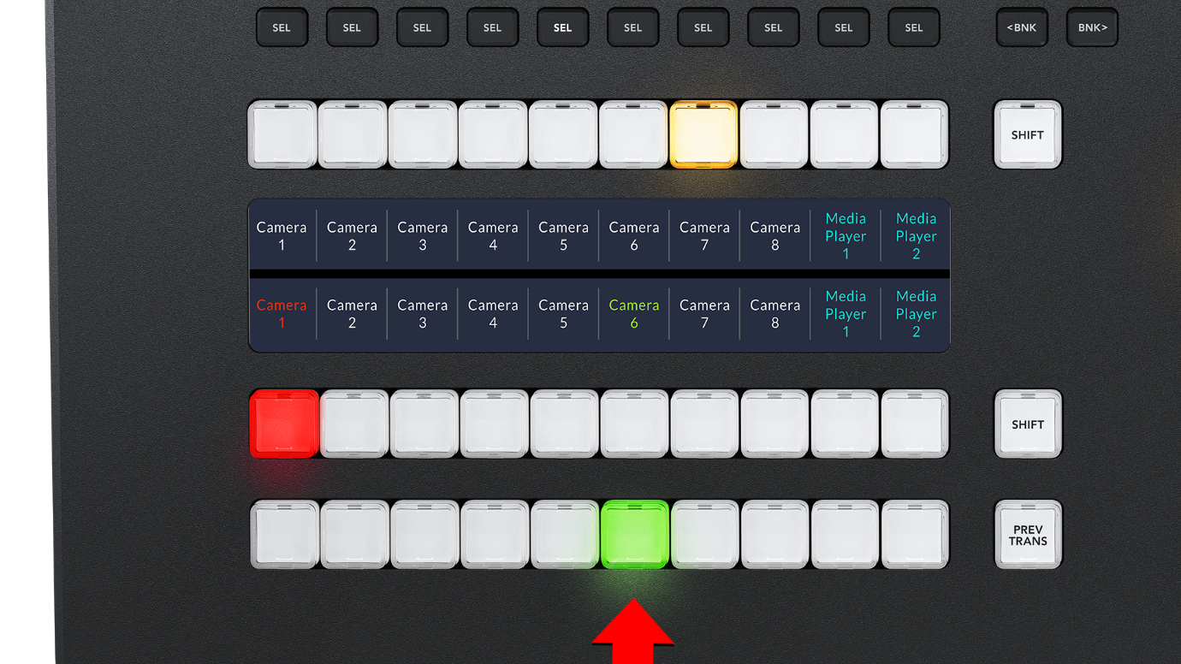

In simple terms – the Preview buttons are used to prepare the next camera frame to be projected to the large screen in front of you.

The following stick can be used to achieve a smooth and seamless transition from Program to Preview:

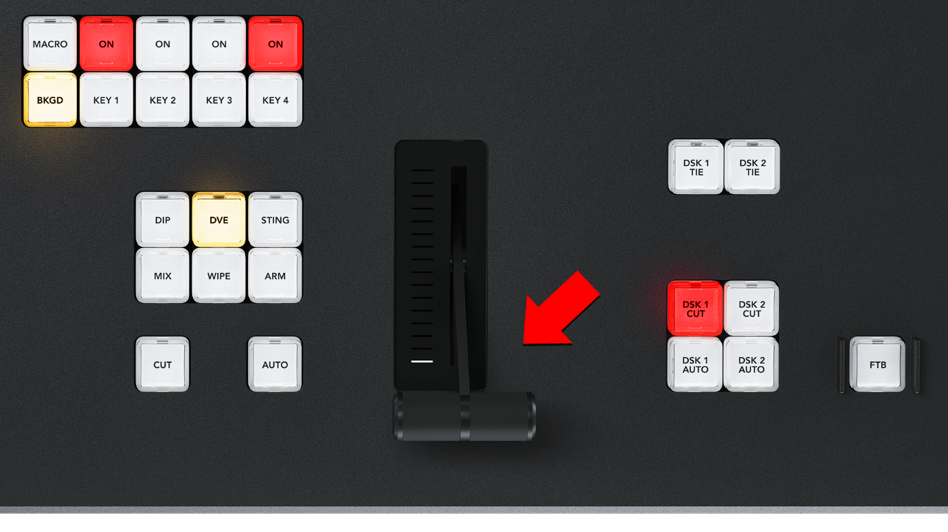

By moving the stick in the opposite direction, you achieve a transition from Preview to Program and vice-versa.